Including Practical issues presentations in SoFs

The burden of treatment and other practical issues related to how a treatment or test affects the patients’
daily life are frequently missing in guidelines and in many tools for shared decision-making.
These practical issues have also been called the “work” of being a patient. An exploration of large database of patient’s reports of burden of treatment and practical issues related to interventions, has identified 15 categories of practical issues ¹:

- Medication routine (e.g., frequency and route)
- Tests and visits (i.e., how many are required to implement an intervention or as follow-up)
- Procedure and device (i.e., what procedures are required, are there any devices involved)
- Recovery and adaptation (i.e., how will recovery typically look like, what additional effort is required, how to manage dependencies)
- Coordination of care (i.e., how does an intervention practically fit with the rest of care)
- Adverse effect, drug interactions and antidotes (i.e., are there specific adverse effects or interactions to manage or anticipate, what is involved to mitigate or manage them, are there existing antidotes to drug interventions)
- Physical well-being (i.e., is there any physical distress that may come with managing practical issues relation to an intervention)
- Emotional well-being (i.e., is there any emotional distress that may come with managing practical issues relation to an intervention)
- Pregnancy and nursing (i.e., how may an intervention be adjusted to pregnancy and nursing)
- Costs and access (i.e., who is paying, and what is required to access the recommendation, assuming it is
available in one’s context)
- Food and drinks (e.g., are there specific directions regarding diet or other health habits)
- Exercise and activities (e.g., how may an intervention impact one’s ability to function in daily life or to
exercise)
- Social life and relationships (e.g., how may an intervention impact one’s social life and interactions)
- Work and education (e.g., how may an intervention impact one’s work or education)
- Travel and driving (e.g., how may an intervention impact the ability to travel or drive a vehicle)

Having data on the categories, which are relevant for an intervention, summarized in SoFs can serve support their translation into tools for shared decision making with patients. ² ³

Examples of how this could be done are displayed in the next page:

Example of a SoF comparing SGLT-2 inhibitors vs Standard of Care, including numerical summary of the evidence of each outcome, followed by a display of relevant practical issue
(Source : MAGICapp: https://app.magicapp.org/#/guideline/5288)
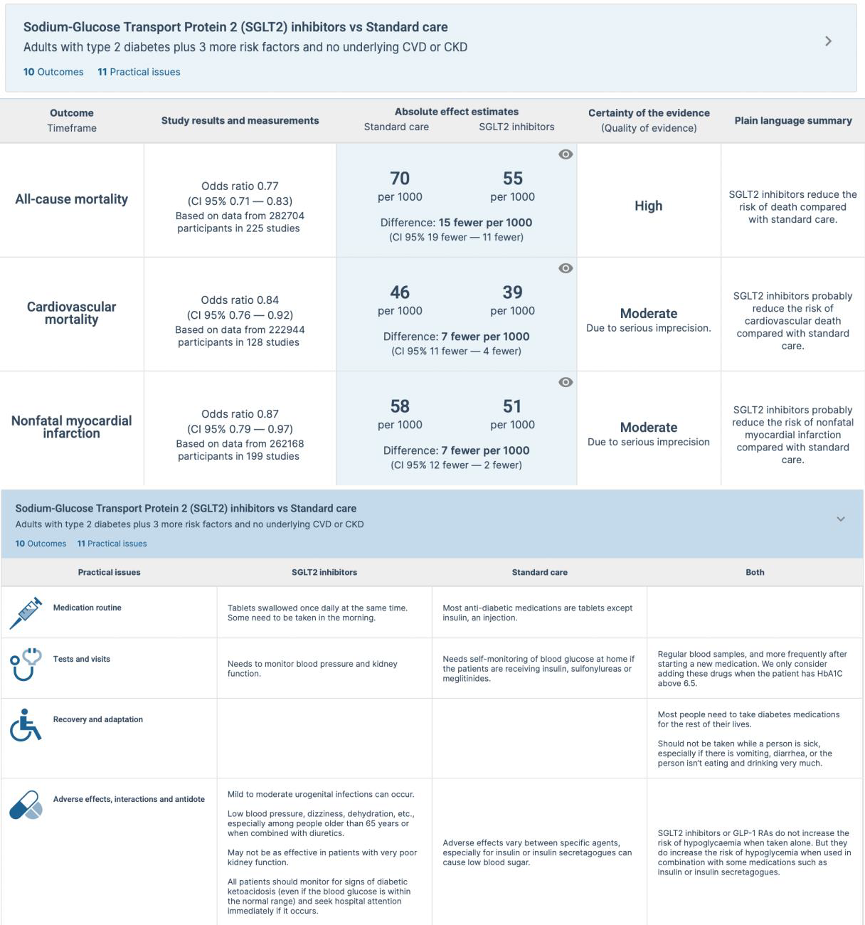

Example of how key practical issue practical issues can be displayed in an infographic
(Source : BMJ Rapid Recommandation : https://www.bmj.com/content/373/bmj.n1091)
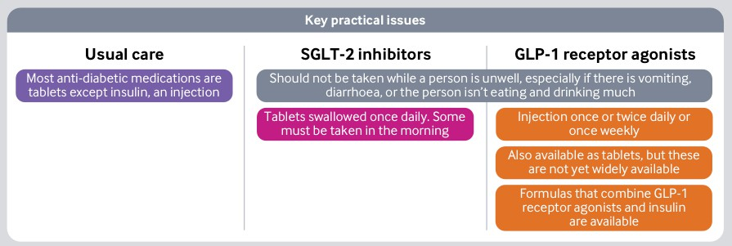

Example of practical issue displayed in a Decision Aid to support shared decision making in the clinical encounter
(Source: SHARE-IT Decision aids in MAGICapp: https://magicevidence.org/decision-aids)
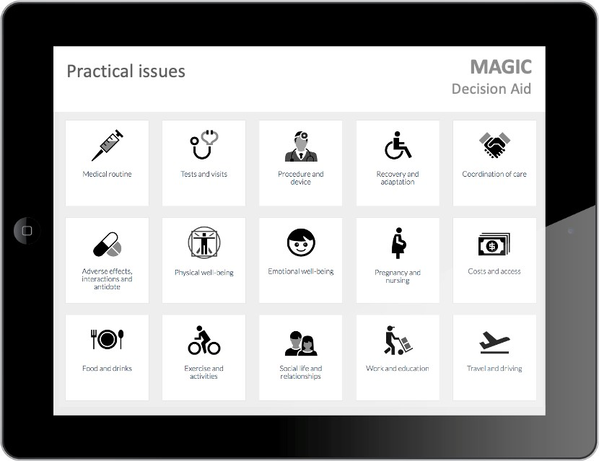

References
- Heen AF, Vandvik PO, Brandt L, et al. A framework for practical issues was developed to inform shared decision-making tools and clinical guidelines. J Clin Epidemiol. 2021;129:104–13. doi: 10.1016/j.jclinepi.2020.10.002
- Agoritsas T, Heen AF, Brandt L, et al. Decision aids that really promote shared decision making: the pace quickens. BMJ. 2015;350:g7624. doi: 10.1136/bmj.g7624
- Heen AF, Vandvik PO, Brandt L, et al. Decision aids linked to evidence summaries and clinical practice guidelines: results from user-testing in clinical encounters. BMC Med Inform Decis Mak. 2021;21:202. doi: 10.1186/s12911-021-01541-7

